  - Notification
    - If a supplier provides nonconforming product (fails to provide product in accordance with established requirements of delivery and quality) they will be notified via a “V-CAR” (Vendor Corrective Action Request).
NOTE: Initial communication may come in the form of more expeditious means prior to the supplier receiving the V-CAR.

4.1.2 The V-CAR provides the supplier with the following information:
- Description of the problem.
- Action required by the supplier.
- Required countermeasure type and due date. [NOTE: All submitted countermeasures must be written in English]

SAMPLE ONLY of WCP Vendor Corrective Action Request (V-CAR)……..

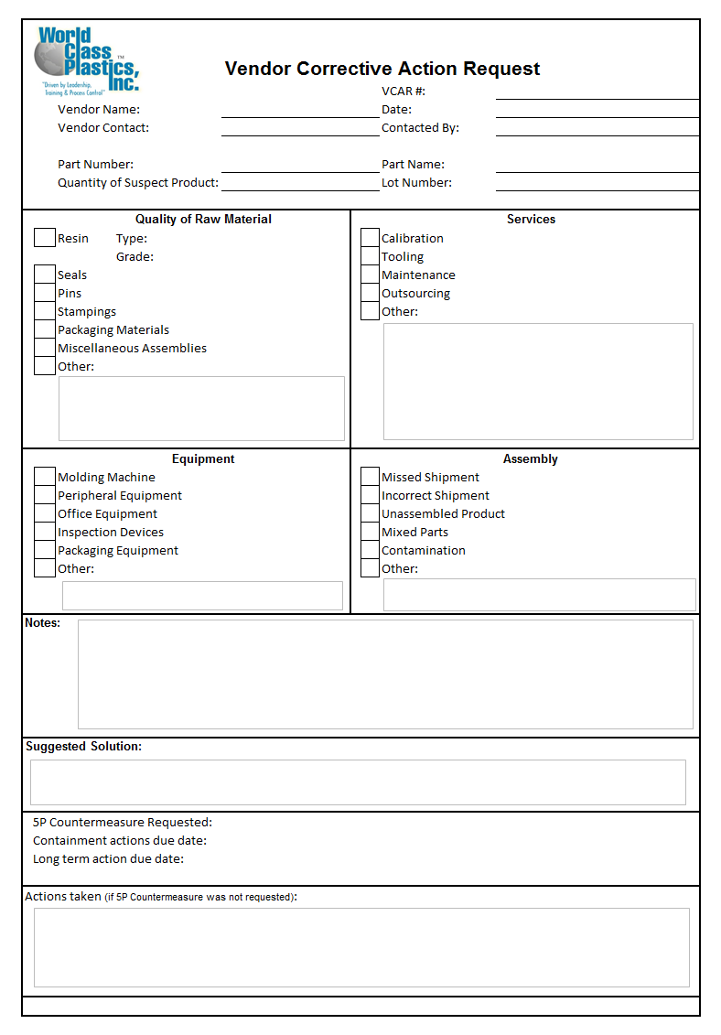

  - Response
    - The supplier is responsible to notify WCP immediately if they (supplier) have been notified by the National Highway Traffic Safety Administration (NHTSA), other governmental authority, or another motor vehicle manufacturer that the product they have supplied to a WCP production facility or to another vehicle manufacturer that is identical to or substantially similar to the product that was supplied to a WCP production facility, could reasonably impact motor vehicle safety or result in non-conformance with Federal Motor Vehicle Safety Standards (FMVS)

    - When the supplier becomes aware of an actual and/or potential nonconforming product, the supplier is required to immediately…

  - Response (continued)

- Undertake inspection, segregation, and/or repair of suspect parts using the following “5C” guideline for problem containment and response…
  - CUSTOMER: (WCP) All affected WCP product should be prioritized and immediately contained and verified according to the following considerations….
    - Does WCP have product at WCP’s customers that is suspect and requires action?
    - Does WCP have product en route to WCP’s customer that is suspect and requires action?
    - Does WCP have finished product at WCP that is suspect and requires action prior to further shipments to WCP’s customer?
    - Does WCP have WIP that is suspect and requires action?
    - Does WCP have product in inventories that is suspect and requires action?
    - Does WCP require immediate replacement of product?

  - CONTAIN: All included affected product that has not been received at WCP…
    - Does the supplier have product in transit to WCP that is suspect and requires action?
    - Does the supplier have product on the shipping dock (prepared for transit to WCP) that is suspect and requires action?
    - Does the supplier have finished product in inventories that is suspect and requires action?

  - CONTROL: Supplier must immediately confirm and initiate control at all stages that are at risk of producing additional suspect product.
    - Does the supplier have product being produced that is suspect and requires action?
    - Does the supplier have scheduled production that could produce additional suspect product and requires action?
    - Does the supplier have items (i.e. tools, inventory, raw materials, orders, drawings, designs, etc…) that could allow additional n/g product to be produced?

  - CORRECT: (countermeasure), the root cause...
    - Utilize a problem solving method such as fishbone, 8D, 5p etc, for identification-correction-confirmation to identify the root cause and provide countermeasure to WCP on or before the due date.
[NOTE: All submitted countermeasures must be written in English.]

  - CONFIRM: that all concerns have been addressed….
    - Has problem ceased, with no re-occurrence?
    - Has all n/g product been returned-reprocessed-scrapped-etc?
    - Does WCP have adequate supplies of good product?

  - Response (continued)

- In addition to the necessary containment and verification, the supplier must…

  - Identify initial shipment of 100% certified product with necessary identification (i.e. IPP referencing WCP V-CAR # and clearly indicating “100% certified product”.)

  - Identify the initial shipment of the product using an IPP (Initial Production Parts) tag referencing the WCP V-CAR #.

  - Analyze the cause(s) of the non-conformance and implement appropriate corrective action.

  - Report results of sorts, suspect lot range information, repairs, investigations and corrective actions to WCP as part of the countermeasure response.

  - Apply countermeasure activities to similar systems or processes and to the supplier's problem history records.

- Ensure initial shipment of countermeasured/verified product is prepared for shipment with necessary identification (i.e. IPP referencing WCP V-CAR # and clearly identified “Countermeasured product”)
NOTE: In the event of a “split shipment” (shipment on which both “100% certified product” and countermeasured product are provided), the individual containers and/or parts must clearly indicate which product is “100% certified product” and which product is “Countermeasured product”.

- A PDR (Performance Deficiency Review) requires the supplier management to provide an onsite presentation at WCP and may be required due to, but not limited to…

  - Failure by the supplier to provide immediate containment and response.

  - Failure by the supplier to provide containment and support to adequately protect WCP from all potential for receiving and/or out-flowing suspect product.

  - Failure by the supplier to provide proper identification of certified and/or countermeasured shipments.

  - Failure by the supplier to obtain extension request or provide acceptable permanent countermeasure to WCP on or before the due date as indicated on the V-CAR.

  - Responsibilities
    - The Supplier is responsible for arranging, instituting, administration of, and on-site management of associates performing work on the supplier’s behalf.

    - The supplier is responsible for the dress and behavior of associates performing work on the supplier’s behalf including…

    - All supplier associates or contracted temporary workers within WCP must wear…
- Eyewear
- Appropriate shoes with closed toe and heel.

    - WCP reserves the right to refuse admittance if clothing is deemed to be unsafe and/or inappropriate.

    - The supplier is responsible for the care and return of any additional safety equipment (e.g. safety glasses, gloves, bump caps, etc…) which may be provided by WCP.

    - Supplier associates must conform to WCP's procedures and policies.

  - COST and MATERIAL

4.4.1 The supplier is responsible to provide the necessary tools and supplies for repair/rework/sort, including 3rd party sort
companies and/or other human resources.

4.4.2 The supplier is responsible for all labor and material, costs of inspection, segregation, and/or repair for
the repair of assemblies/components due to the supplier’s (including sub-supplier’s) non-conforming parts. This includes time spent by WCP personnel containing and/or repairing parts/units.

    - The supplier is responsible for the costs of any expendable items (e.g. gloves, sandpaper, etc.) used in the
inspection, segregation, and/or repair.

    - The supplier is responsible for the cost of any complete or partially complete vehicle or engine that cannot be offered for
retail sale due to the supplier’s non-conforming part.

    - WCP reserves the right to disposition nonconforming parts (repair, scrap or return to supplier). The supplier is responsible for all cost of returning nonconforming product.

    - At WCP’s discretion, suspect lot(s) of parts may be returned to the supplier for inspection, segregation, and/or repair. In this case, the entire lot(s) may be charged as rejects for financial and inventory reconciliation.

    - The supplier shall be responsible for the cost of any non-conforming product provided by the supplier in addition to any collateral damaged parts as result of repair, inspection, or other activities that are a result of the supplier’s non-conformity.

  - COST and MATERIAL (continued)

    - The supplier shall be responsible for any cost related to administration of a problem caused by the supplier providing non-conforming condition (including non-product non-conformities such as but not limited to labeling, FIFO, delivery etc...)

    - The supplier shall be responsible for any assigned costs as result of line stoppages at WCP and/or WCP’s customer as the result of the supplier providing a non-conforming condition.

    - Costs deemed to be the supplier’s responsibility will be communicated via a DM (Debit Memo).

